# 5.9: The continue Keyword

In the previous example, we looked at the break keyword. In this example, we are going to look at the continue keyword. This is another option when we are working with loops. It allows us to skip back to the next iteration without executing all the contents of the loop. It is particularly useful if you need to avoid completing part of the loop in certain situations. In our example, we are going to use it to skip printing the number 5. In this case, we are going to use it in conjunction with the break statement, but it can be used without it.

Update your code from the previous example to include the following elif statement:

elif(counter == 5):

continue

Your full code should be as follows:

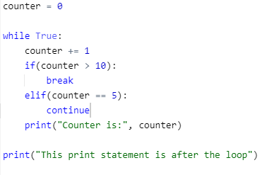

When we run this program, we should have the following output:

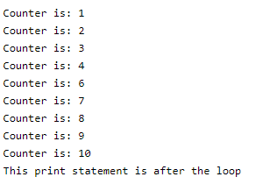

You will notice in this that it didn’t print out the statement which said “Counter is: 5”, this is because the continue keyword forced the loop to return back to the while True: statement, ignoring the print statement.